TITLE (Center, TNR 12pt., Bold)
Author’s name,
Author’s name
e-mail: name@unwe.bg ¹, e-mail: name@unwe.bg ²

Abstract

Sample text inserted for illustration. Replace with abstract text. Your abstract should give readers a brief summary of your article. It should concisely describe the contents of your article and include key terms. It should be informative, accessible and not only indicate the general scope of the article but also state the main results obtained and conclusions drawn. The abstract should be complete in itself; it should not contain undefined abbreviations and no table numbers, figure numbers, references or equations should be referred to. It should be suitable for direct inclusion in abstracting services and should not exceed 200 words (for studies) and 100 words (for articles). Format: Font TNR 12 pt., Justified, Spacing 1,0).
Key words: (up to 10 key words for studies and up to 5 words for articles). Format: TNR 12 pt., alignment in block, spacing 1,15. The key words have to be used common in the main text, as well as to be included in the abstract and if possible in the title.
JEL: For example, JEL: А10, F60 (see https://www.aeaweb.org/jel/guide/jel.php)

Introduction (TNR 12pt., bold, left centred)
Text - (TNR 12 pt., Justified, spacing 1,5). Introduction is a synthesized handout on the subject of the publication for the following sample questions: problem; existing solutions and degree of examination of the problem; limitations of the study; expected results of the author's study.
Main headings / Title (TNR 12pt., bold, left centred)
In the Yearbook of the UNWE are accepted manuscripts for studies and articles in the thematic areas of Economics, Administration and Management, Law, Political Science, Media and Public Communications and related areas.
The volume of the studies is up to 35 pages (each page up to 1800 characters with spaces) -equivalent to full paper between 40 000 and 65 000 characters with spaces including abstract and references.
The volume of the articles is up to 12 pages (each page up to 1800 characters with spaces) equivalent to full paper between 12 000 and 25 000 characters with spaces including abstract and references.
The studies and articles suggested for publication must be structured in separate sections. They should consist of the following parts: introduction, main exposition (titled), conclusion and references. It is recommended to follow the general organizational structure of the scientific publications – introduction, methods, results and discussion. The individual sections are distinguished by headings, with a clear indication of their hierarchy. Format: Font-Times New Roman 12pt, Normal, Justified.
Subtitle (TNR 12pt., bold)
All figures (diagrams, diagrams, Sketches, Web pages/screenshots and photographic images) are transmitted in electronic form. The figures should be made in Excel or Corel Draw, Adobe Illustrator, Adobe PhotoShop.
Pictures in ‘Picture’ format are not acceptable! The numbering is consistent according to the order of citation in the text. The titles of the figures are placed beneath them. Photos and scanned images are transmitted as separate files (format: JPG or TIFF).
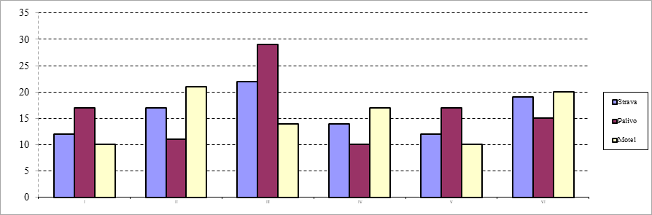
Source: Title (TNR 10pt., left, normal)
Figure 1: Title (TNR 11pt., centered, normal)
Tables should be prepared in Word Table or Excel format. They shuold be numbered sequentially as they are quoted in the text. Each table must have a title. The numbering and the titles of the tables should be placed above them. The necessary explanations shall be given below, by means of the corresponding symbols/signs.
Table 1: Table’s title (TNR 11pt., normal, centered)
TNRoman 10pt, single | TNRoman 10pt, single | TNRoman 10pt, single
TNRoman 10pt, single | TNRoman 10pt, single | TNRoman 10pt, single
TNRoman 10pt, single | TNRoman 10pt, single | TNRoman 10pt, single
TNRoman 10pt, single | TNRoman 10pt, single | TNRoman 10pt, single
Source: Title (TNR 10pt., Justified, Normal)
The authors should use Word Equation to include formulas. The equations should be placed in the middle. The formula numbers must be written in small brackets on the right side of the page! Please, do not use Print Screen or JPG format. E.g:
(1)
Conclusion (TNR 12pt., bold, left centred)
Responds to the main research question, identifies opportunities for further research, originality and relevance of the results.
Notes (TNR 12pt., bold, left centred)
The notes format adopted in the journal is ‘Footnotes’ (on the same page). They are identified in the text by consecutive numbers.
Sponsorship (TNR 12pt., bold, left centred)
The sources of funding of the scientific study shall be provided. The authors should describe the role of these funding sources throughout the workflow – from the staging of scientific research to achieving the final results.
Acknowledgements
Acknowledgements enable you to thank all those who have helped in carrying out the research. Careful thought needs to be given concerning those whose help should be acknowledged and in what order. The general advice is to express your appreciation in a concise manner and to avoid strong emotive language.
References (TNR 12pt., bold, left centred)
A reference list is a complete list of all the sources used in the main text, abstract etc. This list includes information about the sources like the author, date of publication, title of the source and more.
! The manuscript must include as mínimum 10 scientific sources (monografic research, studies, articles, conference proceeding reports) as part of a larger references list. One author may be cited in the reference list maximum twice. Fundamental and classical works in the field may be cited up to three times in the reference list.

A Harvard reference list must:
- Be organised (without numbering) alphabetically by author, unless there is no author then it is ordered by the source title.
- If there are multiple works by the same author these are ordered by date, if the works are in the same year they are ordered alphabetically by the title and are allocated a letter (a,b,c etc) after the date
- Be ordered alphabetically, starting first with the Bulgarian sources.
- The Bulgarian sources are given first in their original way and then transliterated.
For example: Ерхард, Л., (1993). Благоденствие за всички, София, УИ “Стопанство”. (Erhard, L., 1993. Blagodenstvie za vsichki, Sofia: UI „Stopanstvo“).
- For more information on how to cite in Harvard style of referencing, please visit the following page: https://www.mendeley.com/guides/harvard-citation-guide
All references are cited in the text as follow:
(Shmit, 2020)
(Shmmit, 2020, p. 7) especially for text in quotes
(Shmit, 2020; Osborn, 2019)
(Shmit, 2020; Osborn, 2019, p. 7)
In cases as: According to Shmit (2020)
According to Shmit (2020, p. 7)
But for this citing the source is used earlier in the text as follow - (Schmidt, 2020)
For sources in Bulgarian:
(Иванов, 2019)
(Иванов, 2019, p. 7)
- For more information on how to cite in the text in Harvard style of referencing, please visit the following page: https://www.mendeley.com/guides/harvard-citation-guide

***
Manuscripts should be submitted electronically via the electronic platform on the UNWE Yearbook page (http://unwe-yearbook.org/en/journalissues/submit). For more information please write to the email address of the editor (yearbook@unwe.bg).
Before sending, rename the file using the last name (s) of the author (ies). E.g:
Ivanov_Petrov_Y-UNWE.docx

Academic title, scientific degree. Department/ Faculty, University, ORCID. Format: Footnote TNR 10pt., justified, spacing 1,15.
Academic title, scientific degree. Department/ Faculty, University, ORCID. Format: Footnote TNR 10pt., justified, spacing 1,15.
Notes (such as author’s comments)

