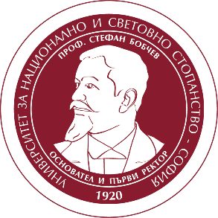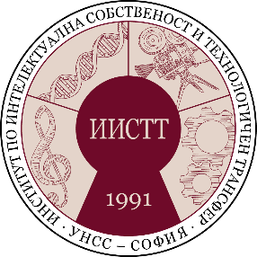
УНИВЕРСИТЕТ ЗА НАЦИОНАЛНО И СВЕТОВНО СТОПАНСТВО
UNIVERSITY OF NATIONAL AND WORLD ECONOMY
ИНСТИТУТ ПО ИНТЕЛЕКТУАЛНА СОБСТВЕНОСТ И ТЕХНОЛОГИЧЕН ТРАНСФЕР„ПРОФ. Д-Р БОРИСЛАВ БОРИСОВ”
INSTITUTE OF INTELLECTUAL PROPERTY AND TECHNOLOGY TRANSFER “PROF. DR. BORISLAV BORISOV”

AUTHOR’S DECLARATION
(academic position, scientific degree, name, surname)

The scientific report presented on the scientific conference is:
1. Author's product /co-author's product when indicating co-authors/ - object of copyright according to the COPYRIGHT LAW in BULGARIA, 1993 and BERN CONVENTION, 1886.
2. The literary sources used are cited in good practice and according to the rules of scientific ethics.
3. It has not been published in other publications, has not been presented in scientific or other forums and will not be used for similar purposes.
4. The author allows the scientific committee of the international conference to use the report for inclusion in a collection of papers of this conference.

Date, Sofia, BG AUTHOR:
Signature

